HDOC-5
PROBLEM STATEMENT: Find the incomplete algorithm & flowchart attached below for today's HDOC Question.
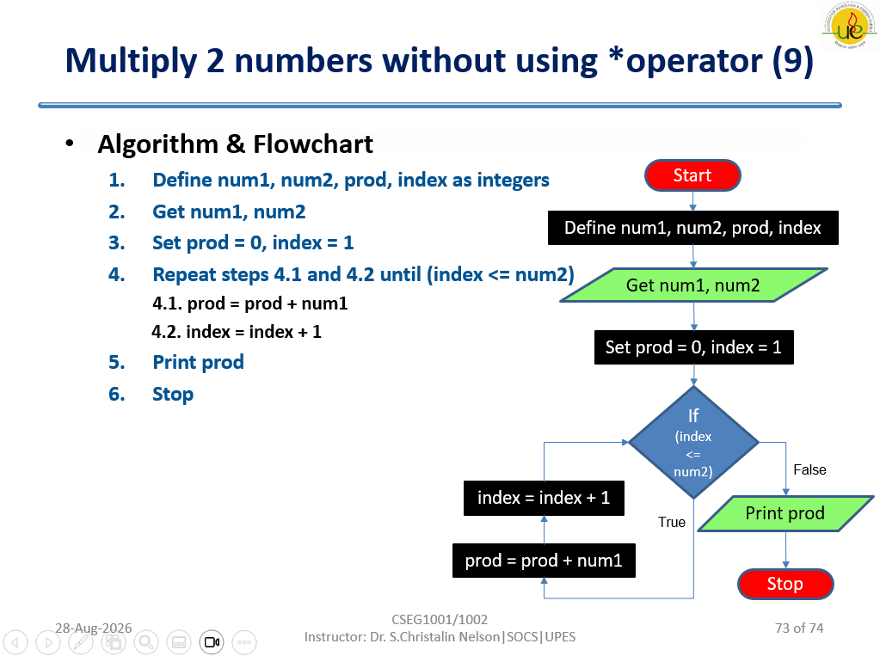
ALGORITHM:
1) Start
2) Define num1, num2, prod, and index as integers.
3) Get num1 and num2.
4) Set prod = 0 and index = 1.
5) Repeat while index <= num2:
- prod = prod + num1
- index = index + 1
6) Print prod.
7) Stop
COMPLETE FLOWCHART:
┌─────────┐
│ START │
└────┬────┘
↓
┌─────────────────────────┐
│ Define num1, num2, │
│ prod, index as integers │
└────────────┬────────────┘
↓
╱────────────────╲
╱ Get num1, num2 ╲
╲ ╱
╲────────────────╱
↓
┌──────────────────┐
│ prod = 0 │
│ index = 1 │
└────────┬─────────┘
↓
◇───────────◇
╱ index <= ╲
╱ num2 ? ╲
◇───────────────◇
│ │
True False
↓ ↓
┌─────────────────┐ ╱────────────╲
│ prod = prod + │ ╱ Print prod ╲
│ num1 │ ╲ ╱
└────────┬────────┘ ╲────────────╱
↓ ↓
┌─────────────────┐ ┌────────┐
│ index = index+1 │ │ STOP │
└────────┬────────┘ └────────┘
│
└──────→ back to
index <= num2?
C PROGRAM:
#include <stdio.h>

int main()
{
int num1, num2, prod = 0, index = 1;

printf("Enter two numbers: ");
scanf("%d %d", &num1, &num2);

while (index <= num2)
{
prod = prod + num1;
index = index + 1;
}

printf("Product = %d", prod);

return 0;
}

